Rights for user to write comments with nagios web-gui

Hello everyone.

We came across with task to allow our users, who work in our first level of technical support, get right to write comment via web-interface. At this moment our colleagues, who work in the first level of technical support, use nagios guest account to do their job. We would like to grant minimum rights to our first level tech support, so we want allow them only right to write comments and rights, that already have nagios guest account.

I have looked inside /etc/nagios/cgi.cfg to find something, that could help us if we create new user account in nagios for that purposes. But among available rights at /etc/nagios/cgi.cfg I couldn't have found something that can help our requirement.

Could you advice me, please, what should I do, what way should I use, where to look at to find solution our question.

By the way, we are using Nagios Core Version 3.5.1.

With hope for help.
Sergey.

I hope someone have any ideas, that could help us, and hope people could share it.

Thanks for your answer “rkennedy”.
I have read link, you have written. Unfortunately I have not found solution for us.

If I use following statments for defined user in /etc/nagios/cgi.cfg:
authorized_for_all_services=
authorized_for_all_hosts=
This user get only rights to view web fields with comments and other fields. But have no right to write comment and have no right to apply any other command via web interface.

If I grant to the user these statments:
authorized_for_all_service_commands=
authorized_for_all_host_commands=
This user will get all rights to execute any command via web-GUI, but we want to grant only command that allow read and write comments.

Quick remark about “authorized_for_read_only=” option.
If we see its comment in file /etc/nagios/cgi.cfg, we can view that “It will also block comments from being shown to read-only users.”
...
# READ-ONLY USERS
# A comma-delimited list of usernames that have read-only rights in
# the CGIs. This will block any service or host commands normally shown
# on the extinfo CGI pages. It will also block comments from being shown
# to read-only users.

authorized_for_read_only=guest
...
It explain why guest user cannot even see comments at all on nagios GUI web pages.

With best regards,
Sergey

Thanks a lot.
I'm very thankful and really appreciate your answers.
It will very help us to find a way what we would do with our difficulties.

With best regards,
Sergey

https://support.nagios.com/forum/viewtopic.php?f=7&t=36687&p=169121#p169121

Rights for user to write comments with nagios web-GUI
Post a reply

7 posts • Page 1 of 1

Rights for user to write comments with nagios web-GUI
by belogrud » Thu Jan 21, 2016 7:24 pm
Hello everyone.

We came across with task to allow our users, who work in our first level of technical support, get right to write comment via web-interface. At this moment our colleagues, who work in the first level of technical support, use nagios guest account to do their job. We would like to grant minimum rights to our first level tech support, so we want allow them only right to write comments and rights, that already have nagios guest account.

I have looked inside /etc/nagios/cgi.cfg to find something, that could help us if we create new user account in nagios for that purposes. But among available rights at /etc/nagios/cgi.cfg I couldn't have found something that can help our requirement.

Could you advice me, please, what should I do, what way should I use, where to look at to find solution our question.

By the way, we are using Nagios Core Version 3.5.1.

With hope for help.
Sergey.
belogrud

Posts: 7
Joined: Mon Dec 07, 2015 6:34 pm

Top

Re: Rights for user to write comments with nagios web-GUI
by rkennedy » Thu Jan 21, 2016 9:10 pm
The document relating to permissions for users can be found here, https://assets.nagios.com/downloads/nag ... iauth.html

Take a look at it, and it should clear up any questions you may have. I believe that the permission needed for a note is authorized_for_all_services and authorized_for_all_hosts.
rkennedy

Posts: 1398
Joined: Mon Oct 05, 2015 7:45 pm
Location: /usr/local/nagios/

Top

Re: Rights for user to write comments with nagios web-GUI
by belogrud » Fri Jan 22, 2016 1:38 pm
rkennedy wrote:The document relating to permissions for users can be found here, https://assets.nagios.com/downloads/nag ... iauth.html

Take a look at it, and it should clear up any questions you may have. I believe that the permission needed for a note is authorized_for_all_services and authorized_for_all_hosts.

Thanks for your answer and wishes to help us.
I have read link, you have written. Unfortunately I have not found solution for us.

If I use following statments for defined user in /etc/nagios/cgi.cfg:
authorized_for_all_services=
authorized_for_all_hosts=
This user get only rights to view web fields with comments and other fields. But have no right to write comment and have no right to apply any other command via web interface.

If I grant to the user these statments:
authorized_for_all_service_commands=
authorized_for_all_host_commands=
This user will get all rights to execute any command via web-GUI, but we want to grant only command that allow read and write comments.

Quick remark about “authorized_for_read_only=” option.
If we see its comment in file /etc/nagios/cgi.cfg, we can view that “It will also block comments from being shown to read-only users.”
...
# READ-ONLY USERS
# A comma-delimited list of usernames that have read-only rights in
# the CGIs. This will block any service or host commands normally shown
# on the extinfo CGI pages. It will also block comments from being shown
# to read-only users.

authorized_for_read_only=guest
...
It explain why guest user cannot even see comments at all on nagios GUI web pages.

With best regards,
Sergey
belogrud

Posts: 7
Joined: Mon Dec 07, 2015 6:34 pm

Top

Re: Rights for user to write comments with nagios web-GUI
by belogrud » Fri Jan 22, 2016 4:16 pm
Does anybody know - newer nagios version, than we use to, or even enterprise nagios version - is it supports described above feature or no?
belogrud

Posts: 7
Joined: Mon Dec 07, 2015 6:34 pm

Top

Re: Rights for user to write comments with nagios web-GUI
by tmcdonald » Fri Jan 22, 2016 10:58 pm
belogrud wrote:This user will get all rights to execute any command via web-GUI, but we want to grant only command that allow read and write comments.

There is no option to allow *only* reading and writing comments, and in XI we are working to make the permissions more granular but this is not currently available.
First Bowie, now Rickman. Curry, don't you dare.
tmcdonald
Divides by Zero

Posts: 6435
Joined: Mon Sep 23, 2013 4:40 pm

Top

Re: Rights for user to write comments with nagios web-GUI
by lmiltchev » Fri Jan 22, 2016 11:12 pm
I was able to accomplish this in Nagios XI and the "Object Notes" component. Here's the security settings I used for my user:

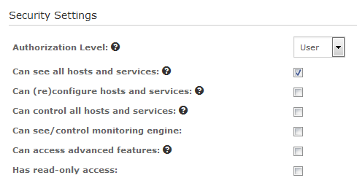
example01.PNG (9.21 KiB) Viewed 17 times

I had to modify the "objectnotes.php" and the "objectnotes.inc.php" files a bit in order to allow all users to add/edit notes. This way all users can post notes, but they can't modify host/services, run external commands, etc. Example:

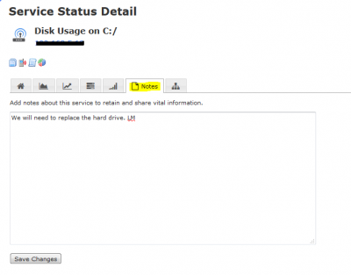
lmiltchev
Bug Hunter Extraordinaire

Posts: 7377
Joined: Mon May 23, 2011 8:15 pm

Top

Re: Rights for user to write comments with nagios web-GUI
by belogrud » Mon Jan 25, 2016 12:40 pm
Thanks a lot.
I'm very thankful and really appreciate your answers.
It will very help us to find a way what we would do with our difficulties.

With best regards,
Sergey

